ADDCB CDDAC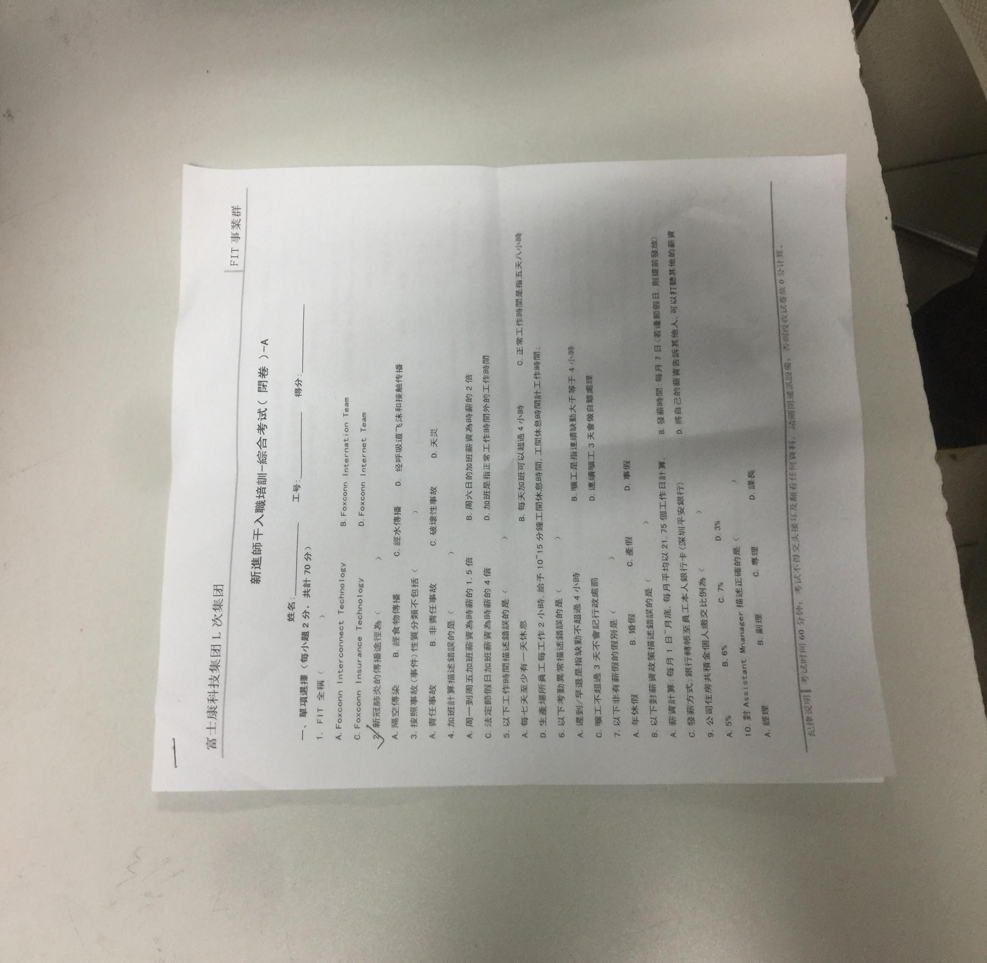

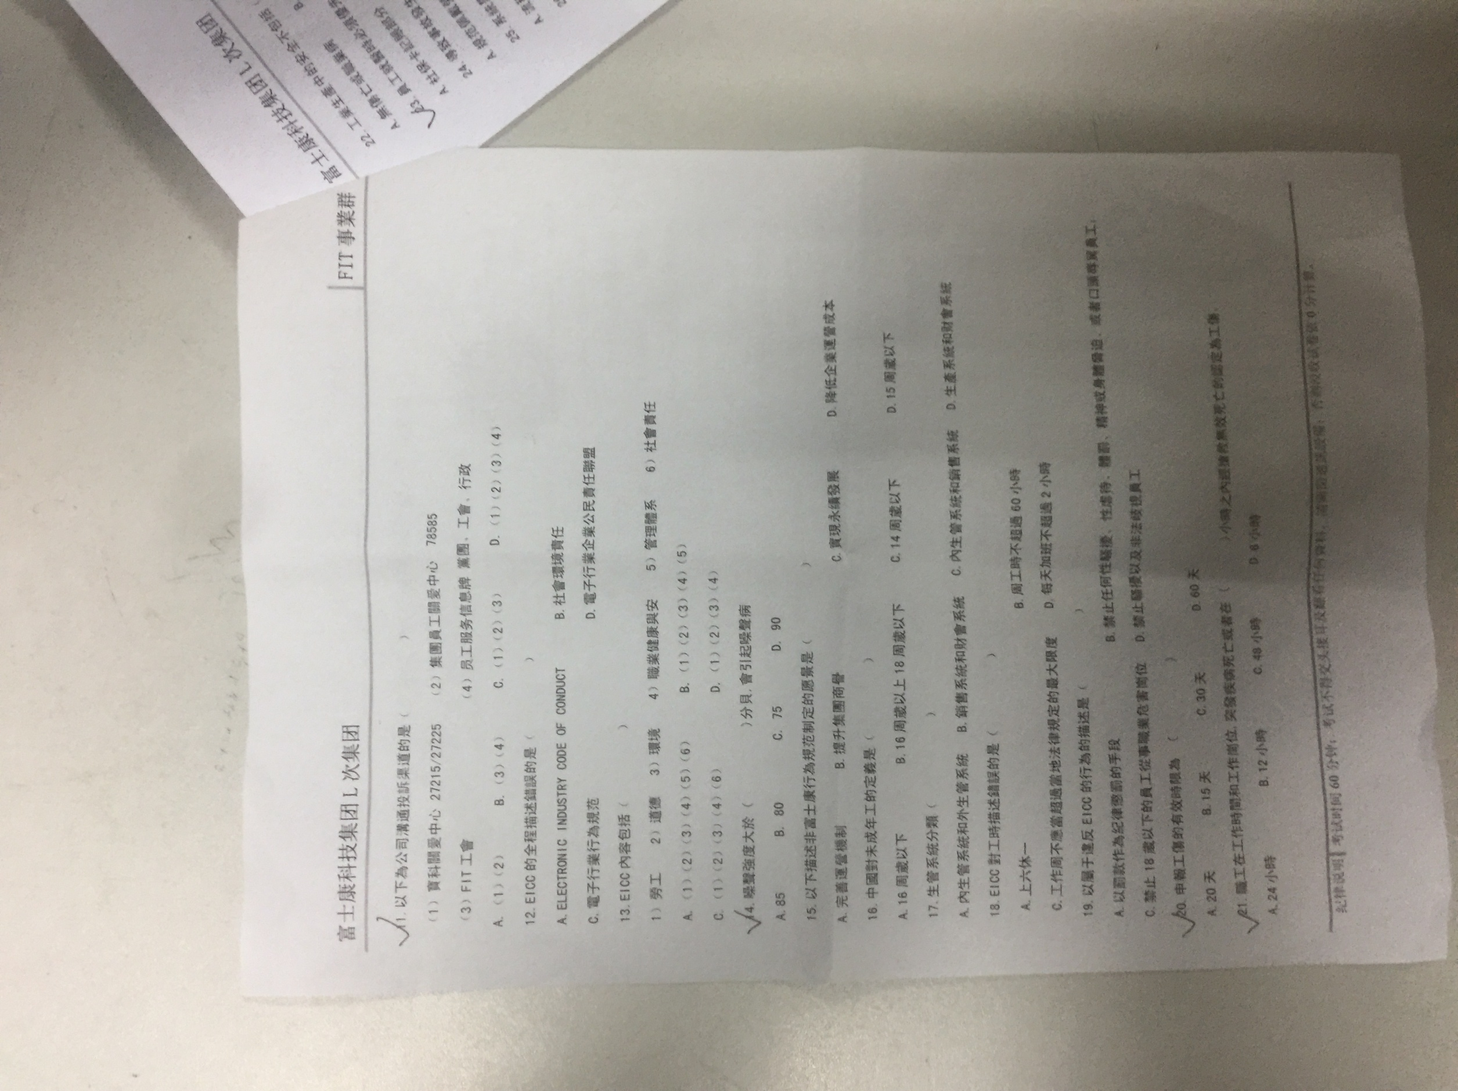DBBAD BAAAC

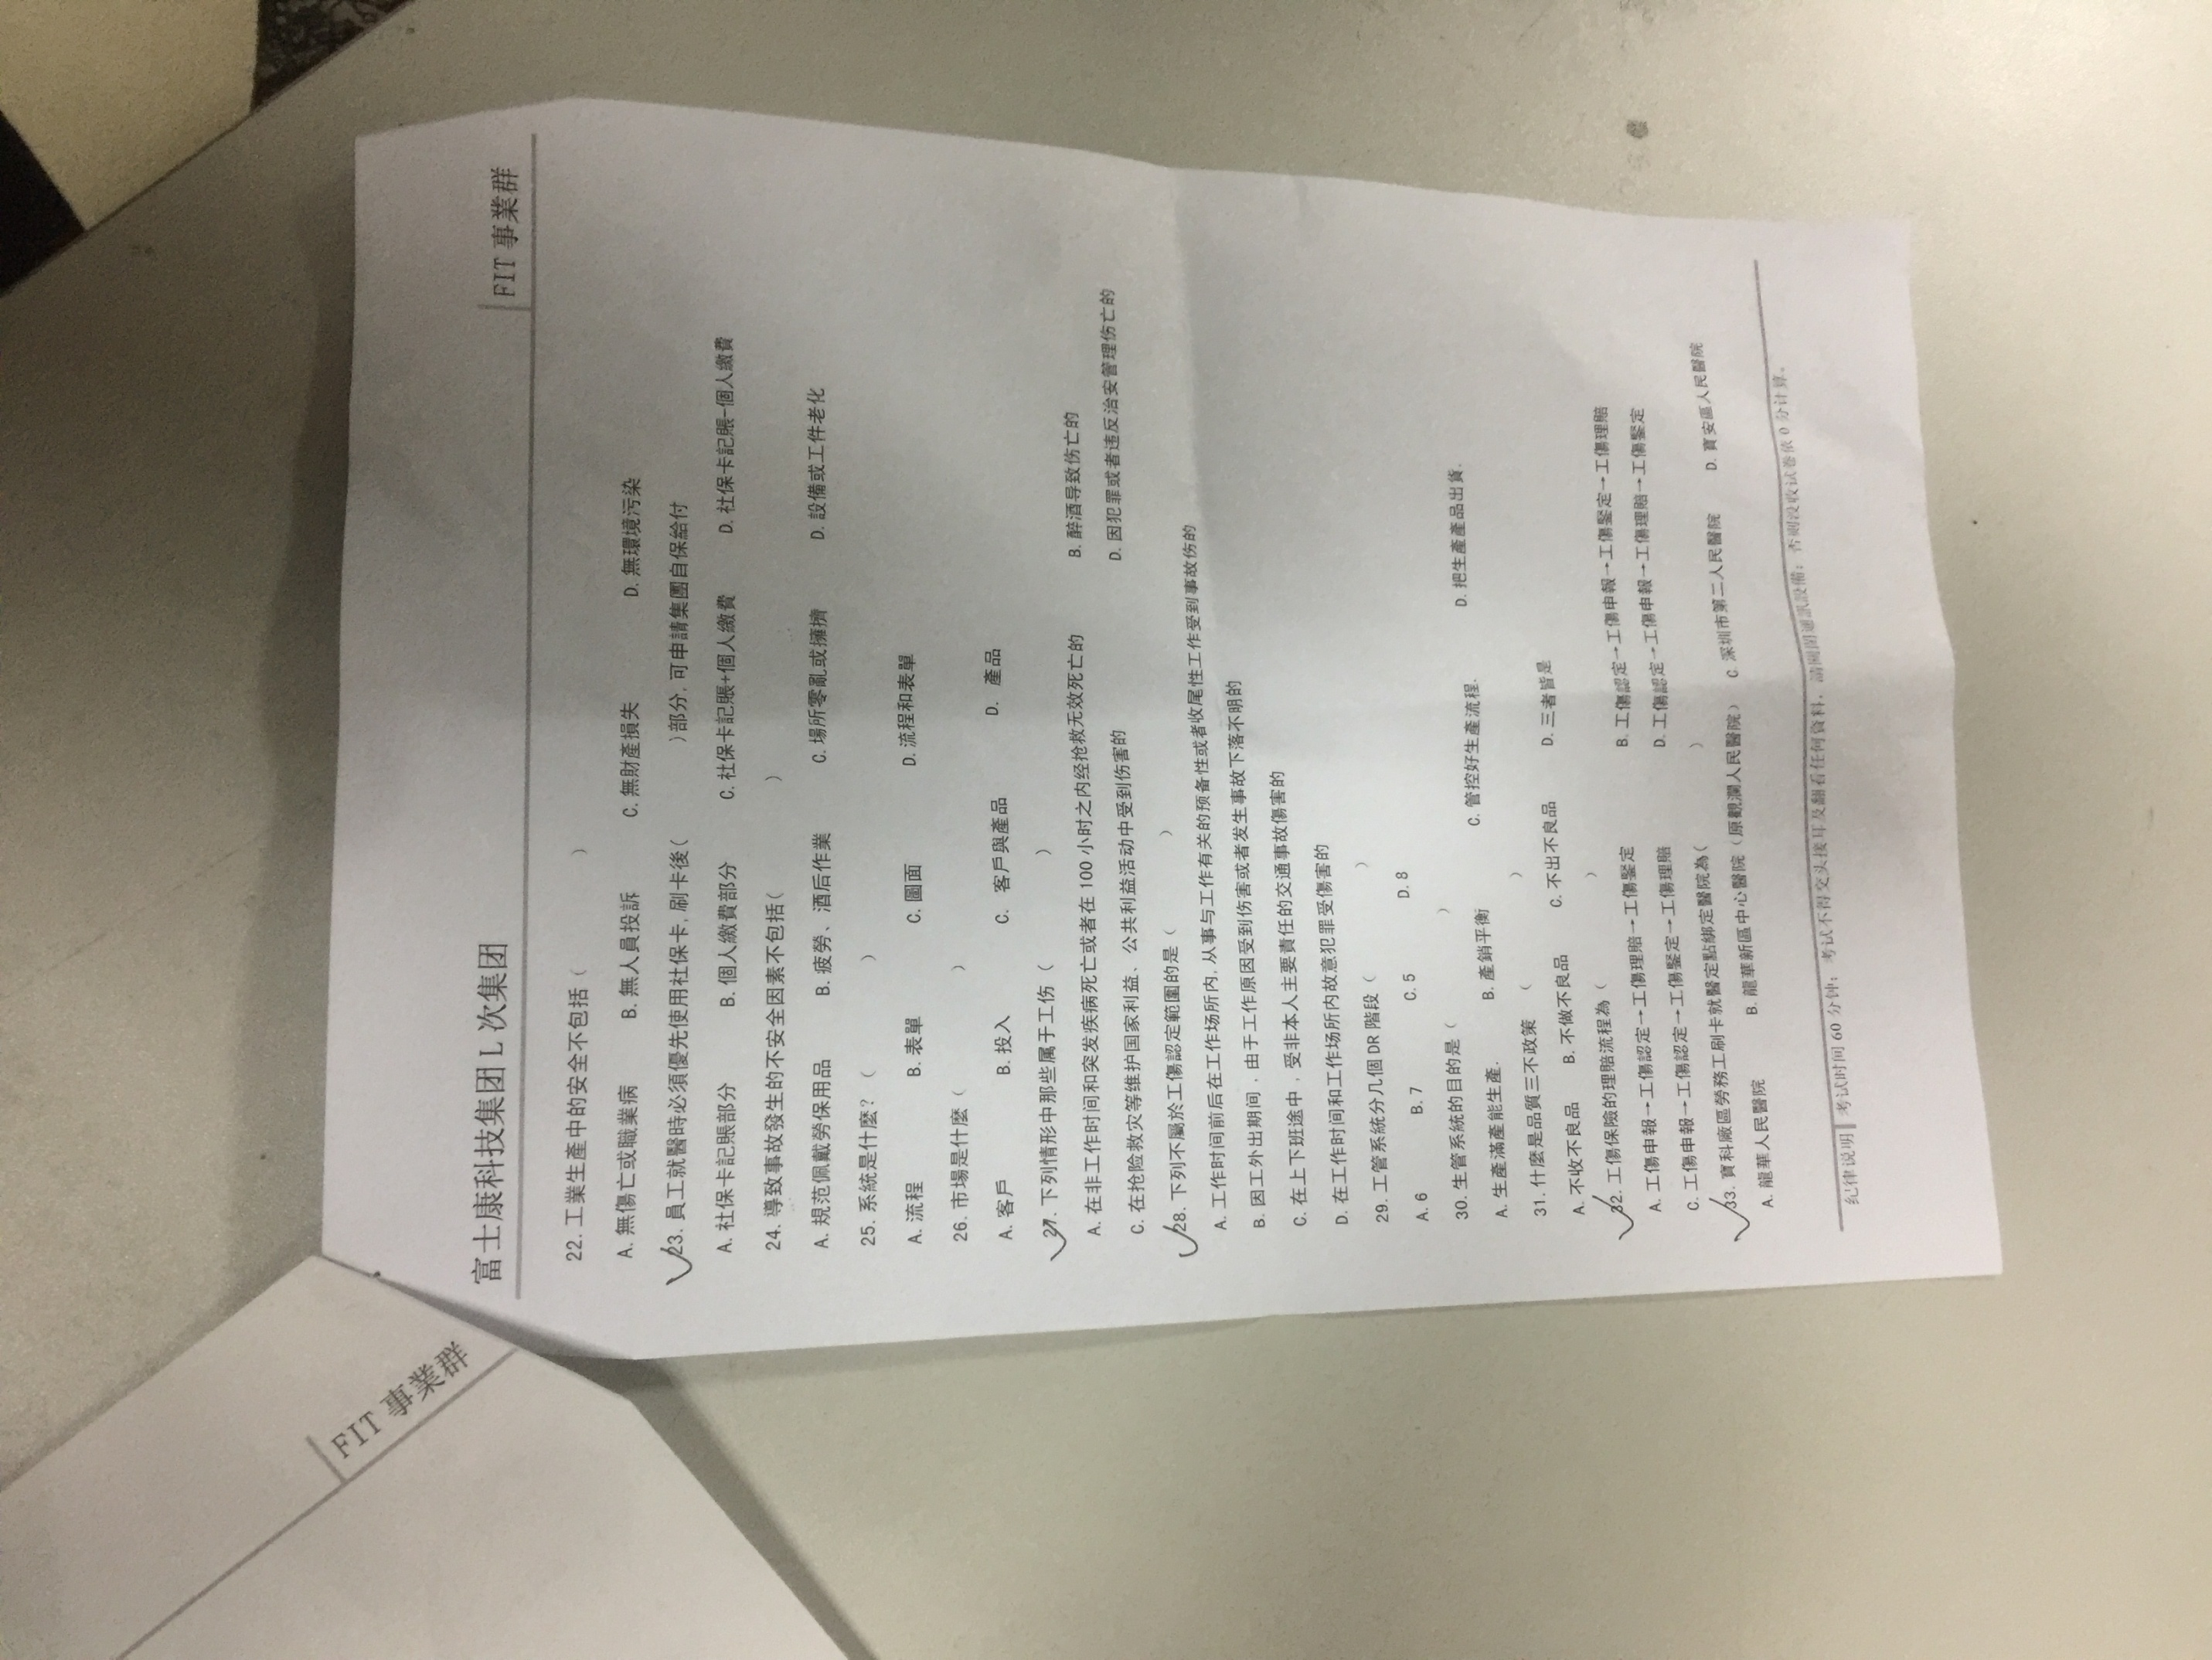

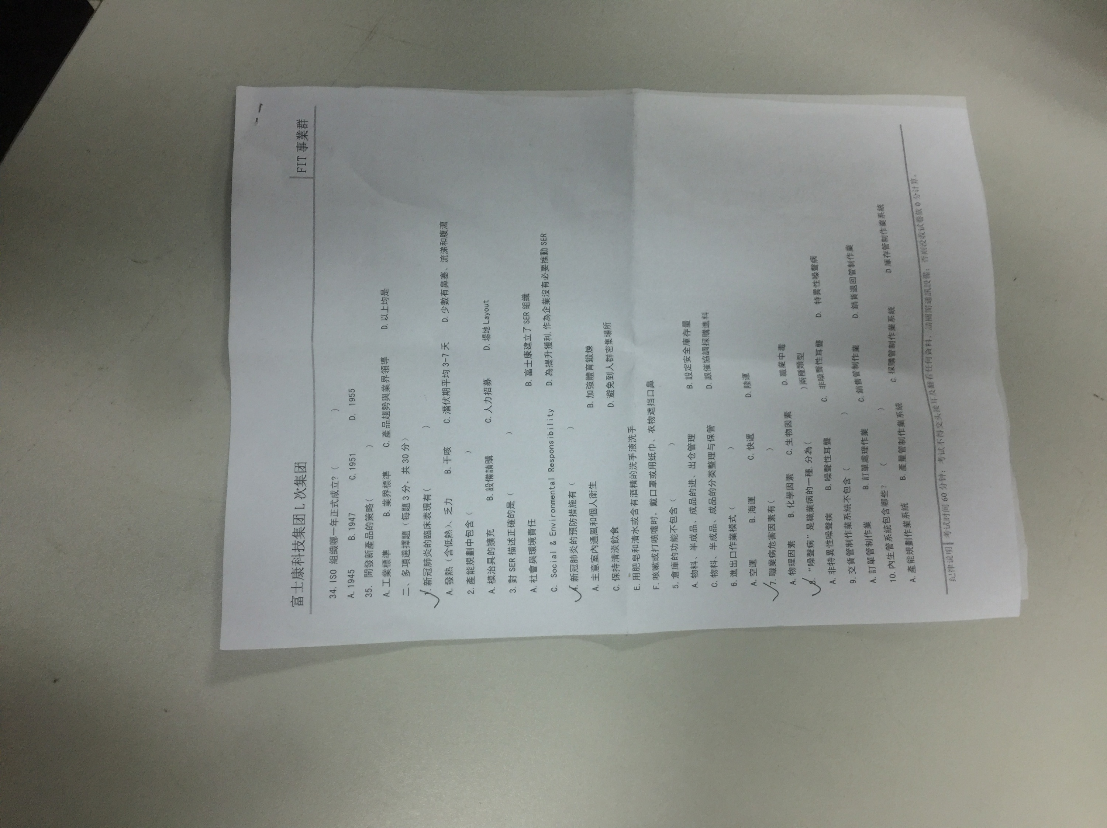

CBBAD CCDBB DCBBD

多選 AB ABCD ABC ABCDEF BD ABCD ABC AD CD ABCD